Vea Margaret Mafile'o

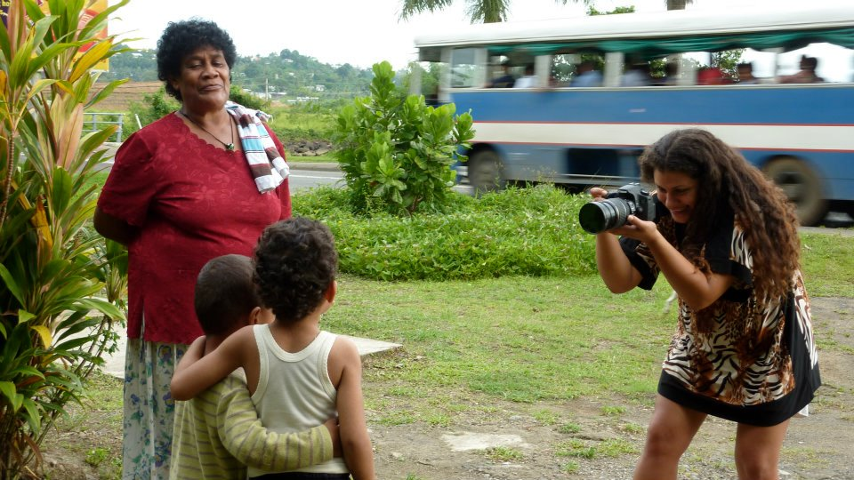

Biography
b. 09-11-81, Auckland
Vea Mafile`o is of Tongan, English/Scottish descent. She was born in Hamilton, New Zealand and raised on a dairy farm in the Waikato. At different times of her childhood she also lived in Tonga.

Vea worked as a scuba diver in Vava`u. She then completed a Bachelor of Visual Arts Degree
from Auckland University before completing a Graduate Diploma in Fine Arts majoring in ‘Moving Image Installation’. Vea is currently working in film and television as a freelance Director/Art Director/ Camera OP

Vea maintains close ties with her Tongan family and often returns with her sister, photographer Emily Mafile`o to Tonga, where she captures the majority of her raw footage. Vea explores issues of her identity and of being multicultural and in recent years she has produced works on Tonga`s political evolution. Her most celebrated work “Sunsets on The Kingdom” was based on the passing of King Taufa`ahau Tupou IV in 2006. This was the first of a trilogy of installation and film she calls Digital Kava circles. The second, titled “Who will douse the Kingdom?”, was based on the infamous 2006 September 16th riots. The third piece of work titled “The Kingdom of new beginnings” celebrates the Coronation of the new king, King George Tupou V in 2007.

Her new lot of Art works explores environmental issues in the Kingdom of Tonga mainly the Ha’apai group. Both natural and man inflicted such as the devastating effects of Tropical Cyclone Ian the sea levels rising.

Vea lives with her partner, 4 year old son and baby in South Auckland, New Zealand.

Nominations

2011 Asia Pacific Breweries Foundation Signature Art Prize 2011
Nominator- Ruth McDougall, Associate Curator, Asian and Pacific Art
Exhibitions

2014 Tonga ‘I Onopooni: Tonga Contemporary, Pataka Museum (Group Show)

2013 Tongan to the Bone, OtaraCube, Otara ( joint installation with Emily Mafile’o)

No’o Fakataha, Atenisi University, Tonga (Group Show)

2012 Matala No’o Fakataha, Mangery Art Centre (Group show)

2010 'Au Mei Moana- Kava Kuo Heka Festival, Nukualofa, Tonga (Group show)

2008 Date Line: Contemporary Art of the Pacific - Govett-Brewster Art Gallery, New Plymouth (Group Show)

2007 Who will douse the kingdom? – te-tuhi (Group show)

Perspectives- August 2-31st, Creative New Zealand Offices, Auckland

2006 The Sun Sets on The Kingdom Manukau Institute of Technology Graduation show (Group show)

2004 Margins- Creative New Zealand offices, Auckland (Combined Show with Teariki Engu)

Birds of Flight, Everyday Super Women - Art Net, Otara Town Centre (Group Show)

Iris Fisher Awards te tuhi- the mark

2003 Tongan Youth Toutupu Trust Exhibition, 4th – 25^{th October} (Group Show)

Pasifikaha, Art Net gallery, Otara, Pasifikaha Exhibition (Group Show)

Nuimui, Black Room, Lakeside convention centre (Group Show)

Pasifikaha Te Galu Fo`ou – The New Wave, te tuhi- the mark (Group Show)

2002 Pacific Art Awards (Group Show)

Manukau Youth Art awards- te tuhi/ the mark (Group Show)

2001 Pacific Art Awards Exhibition (Group Show)

KoKonutti Konection, Sands Gallery, Hamilton 18th-30th November (Combined Show with Emily
Mafile`o)

2000 Pacific Art Awards Exhibition (Group Show, Open Section Winner)

1999 Pacific Art Awards Exhibition (Group Show)

1998 Pacific Art Awards Exhibition (Group Show, Winner Secondary School Section)

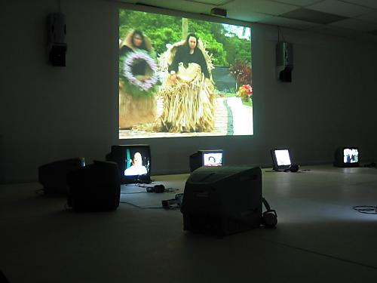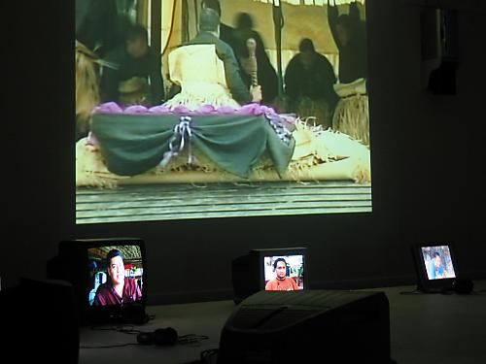
“Sunsets on the Kingdom” Installation 2006 MIT “Sunsets on the Kingdom” Installation 2006 MIT

Curated Exhibitions

2004 Margins – Creative New Zealand Office, Auckland. (In joint curation with Teariki Engu)

2003 Pasifikaha, ArtNet gallery Otara

Pasifikaha Te Galu Fo`ou, te tuhi-the mark (With Emily Mafile`o)

2001 Kokonutti Connection, Sands Gallery (With Emily Mafile`o)

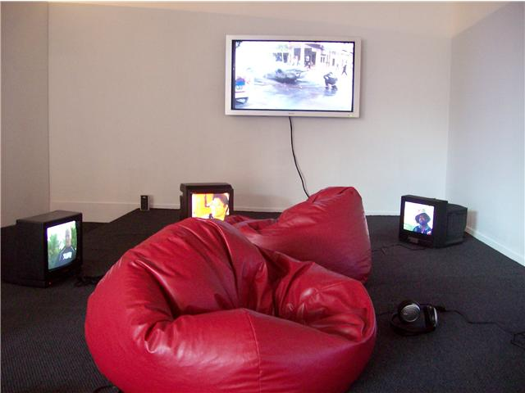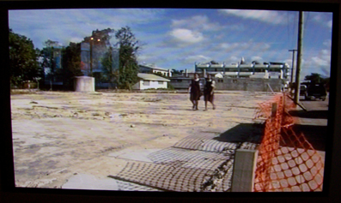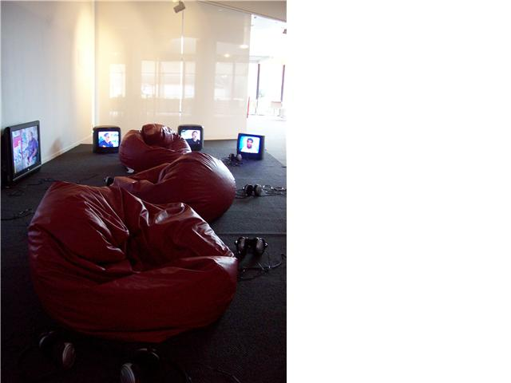
“Who will douse the Kingdom” installation 2007, Te tuhi
Television
2011- ongoing Inserts Director “ VPMusic Awards” (TV1)
Producer: Ngaire Fuata

2011- ongoing Inserts Director “NZ PI Sports awards” (TV1)
Producer: Ngaire Fuata

2011- ongoing Inserts Director- “Samoan Sports awards” (TV1)
Producer: Ngaire Fuata

2013- 2014 Director- “Home Krew” (TV2)
Producer: Nicole Hoey and Keith
http://tvnz.co.nz/home-krew/video

2012- 2013 Tonga Stage Director– “ASB Polyfest” (TVNZ)
Producer: Lisa Taouma
https://www.youtube.com/watch?v=p3_NopHfFt8

2012- ongoing Director/ Set Dresser – Fresh” (TV2)
Producer: Lisa Taouma
https://www.youtube.com/watch?v=rqSk6poI_ck

2012- 2013 Director – IAM TV (TV2)
Producer: Lanita Ririnui, Anahera Higgins

2011 Art Director- “What’s in our foods” (TV3)
Producer: Simone Harris

2011 – 2008 Stage Camera Director – “ASB Polyfest” (TVNZ)
Producer: Lisa Taouma

2008 - ongoing Director/Reporter – “Tagata Pasifika” (TVNZ)
Producers: Stephen Stehlin

2010 - 2006 Art Director – “Pacific Beat Street” (TV3)
Producers: Drum Productions

2008 – 2008 Camera Operator – “Pacific Beat Street” (TV3)
Producers: Drum Productions

2009 – 2004 Art Director Assistant- “Pacific Beat Street” (TV3)
Producers: Drum Productions

2009 Art Director – “Whanau” (Maori TV)
Producers: Cinco Cine

2005 Art Director assistant/ Set builder- “The Mika Show” (Maori TV)
Producer: Mika and Mark James Hamilton
Film

2013 Actor, Art Director – “Broken Silence” (Short Film)
V48 hours film festival – Sir Peter Jackson Choice finalist
http://www.48hours.co.nz/screening-room/2013/auckland/broken-silence/

Art Director- Last Saint ( 1st Trailer)
Producer: Rene Naufahu

2012 Art Director – “Daylight Robbery” (Short Film)
V48 hours film festival – Sir Peter Jackson Choice finalist
http://www.48hours.co.nz/screening-room/2012/auckland/daylight-robbery/

2011 Art Director/Set Designer- “Finding Honk” (Feature Film)
Producer: Eldon Booth
https://www.youtube.com/watch?v=UkeWBtl2xMU

Actor, Art Director – “The Box” (Short Film)
V48 hours film festival

2010 Art Director – “Reggae is My Heart” Babylon Riddim (Music Video)
NZonAir, Youth Performance Trust

2010 Actor, Art Director – “Carousel” (Short Film)
V48 hours film festival – Sir Peter Jackson Choice finalist
https://www.youtube.com/watch?v=pFS72H3KP6U

2009 Art Director – “Fanatics” (Short Film)
V48 hours film festival – Peter Jackson Choice finalist

2008 Assistant Director/ Art Director “Mua O: An Introduction to Gagana Samoa”.
NZ Ministry of Education. (DVD Teaching Resource).

2008 Art Director – “In Search of Bigfoot”
V48 hours film festival - Peter Jackson Choice finalist

2006 Art Director – “365 days”
V48 hours film festival – Auckland finalist

2006 – 2007 Set Dresser – “Map Reader” (Feature film)
Producer: John Davies

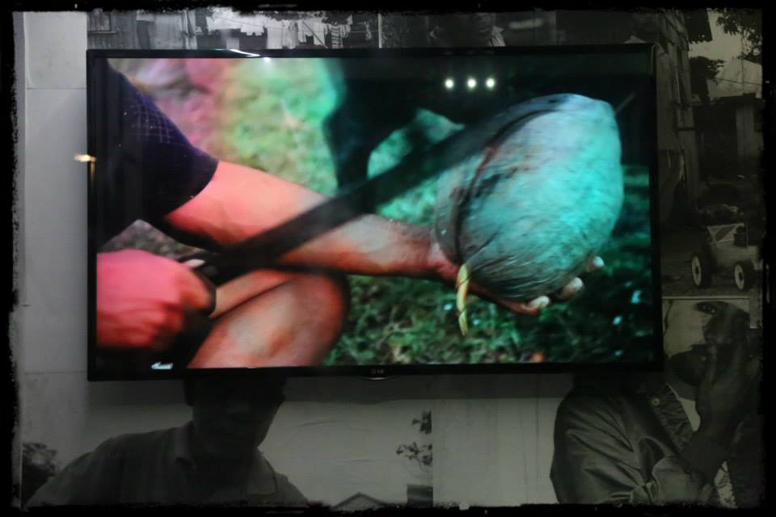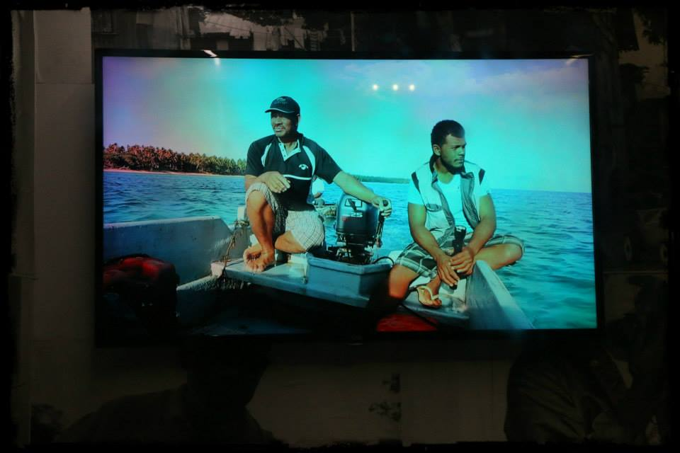
“Tongan to the bone” installation 2013, OtaraCube
WEB PRODUCTION
2013- ongoing

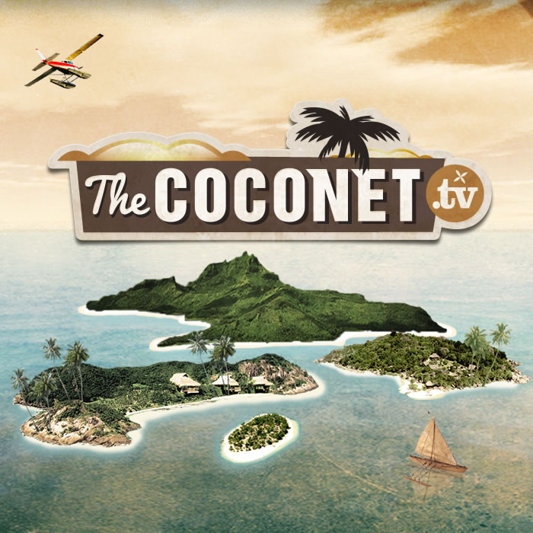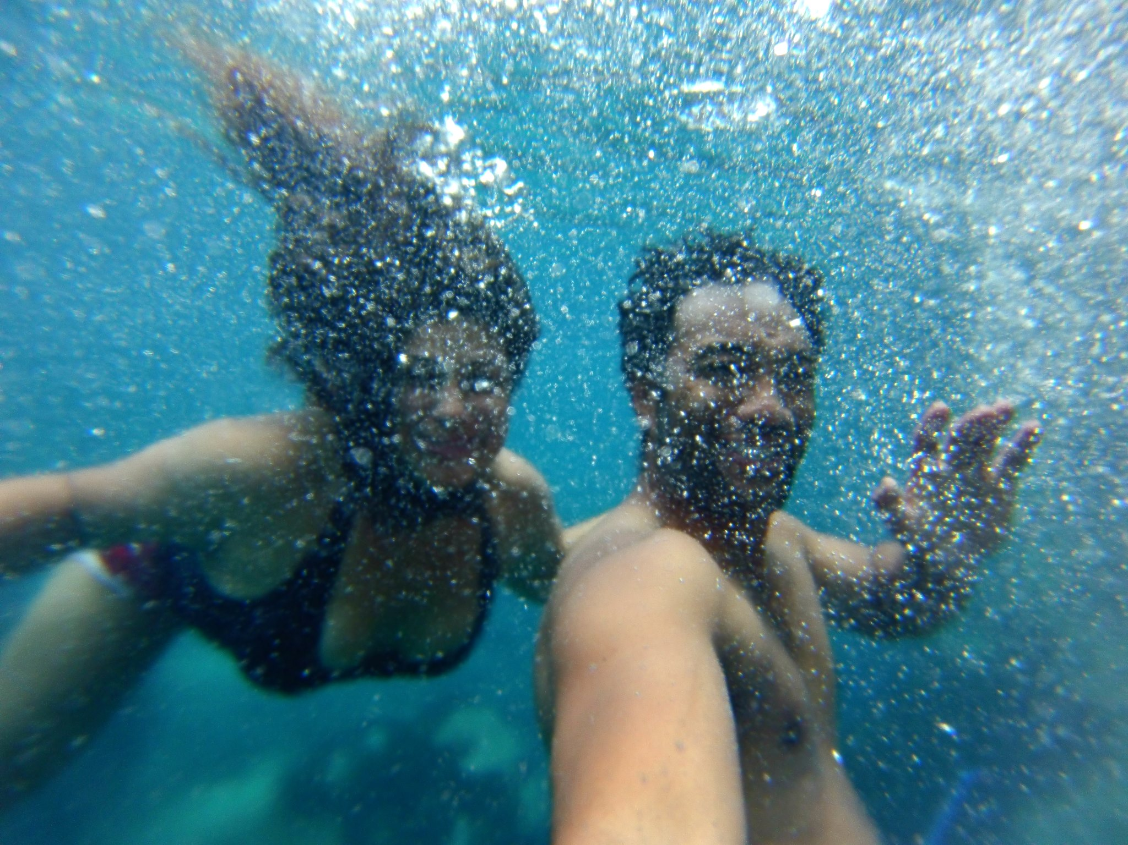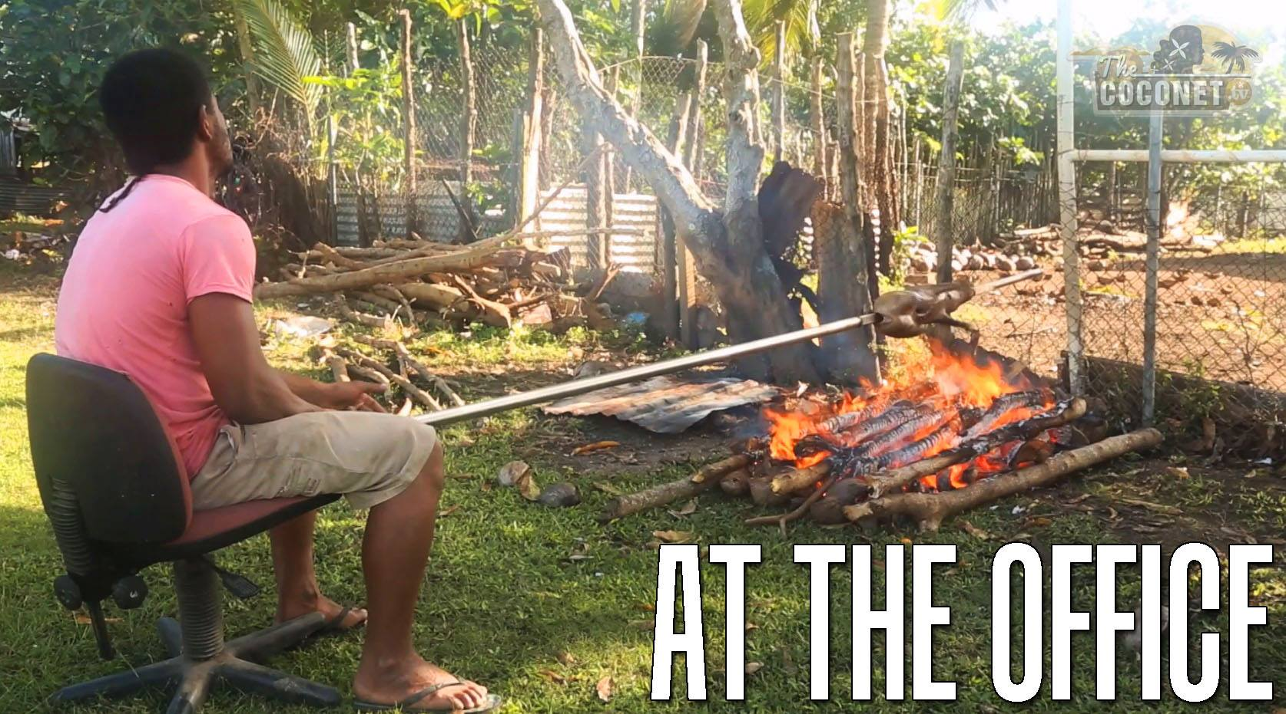
Website channel – www.thecoconet.tv (2013 - 2014 ongoing)
http://www.thecoconet.tv/how-to/catch-an-octopus-feke/
http://www.thecoconet.tv/how-to/ngatu-tonga/
Role: Video insert Director
Duties: Field, and post production director, writer, Cam OP
Producers: Flying Jandals – Lisa Taouma

Events

2014 - 2007 Director of Event Dressing (TVNZ)
New Zealand Pacific Island Music Awards 2010
Pacific Music Awards Committee

2012 – 2010 Pre-Judging Dressing
“Westfield Style Pasifika” (TVNZ)
Drum Productions

2013 - 2007 Director of Event Dressing
Smokefree Pasifika Beats
Youth Performance Trust

2008 Director of Event Dressing
ASB TVNZ Polyfest Showcase 2008

Education

Grad Diploma Fine Arts (Auckland University 2007)

Bachelor of Visual Arts, Major- Sculpture (Auckland University 2006)
Minor-Moving image and Painting

2/64 Park Ave Ph (09) 279 3136
Papatoetoe (021)2040056
Auckland mafileov@gmail.com

